Lab sheet - 0 3 CIS31041-Practical for Data Mining
Reg No: SEU-IS-19-ICT-003
Title: Python for Data Mining - 1
Aim: Work with Google Colab
Task: Getting practises with python
Getting practises of colab Exercises
- Basic mathematical operations using python
  - Addition
  - Subtraction
  - Multiplication
iv. Division
  - Floor Division
  - Power

- Working of String array
  - Print the string array
  - Multiply the string array
  - Retrieve a character iv. Retrieve the set of character
  - Concatenate the string
  - Find the length of the string array

- List
  - Introduction to list
  - Assigning value for index
  - Assigning multiple values
  - Length of list
  - Append the element
  - Remove the element
  - Copy the list

- Control flow structure
  - If -elif-else ii. While
iii. For iv. Continue v. Br eak
- Basic Function in python
- Stack (Last In First Out (LIFO))
  - Create the stack
  - Append the stack
  - Remove the element in stack

- Queue (First In First O ut ( FIFO))
  - Create the queue
  - Insert the element in queue iii. Remove the element in queue

Basic mathematical operations using python
- Addition
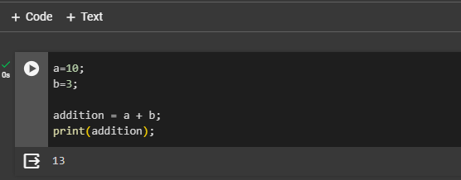

- Subtraction

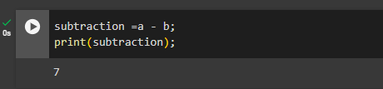

- Multiplication

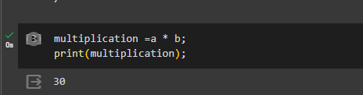

- Division

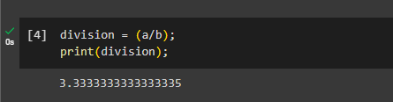

- Floor Division
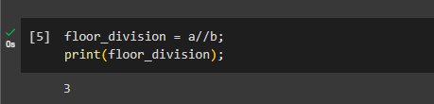

- Power
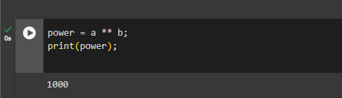

- Working of String array

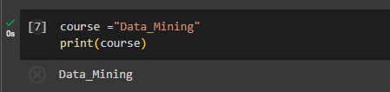
- Print the string array

- Multiply the string array
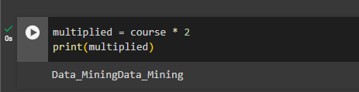

- Retrieve a character
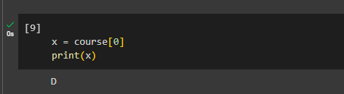

- Retrieve the set of character
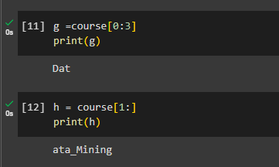

- Concatenate the string
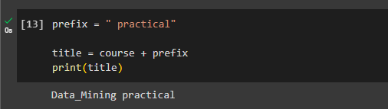

- Find the length of the string array
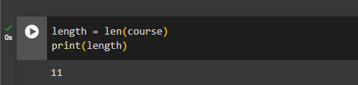

- List
  - Introduction to list
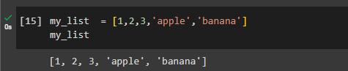

  - Assigning value for index
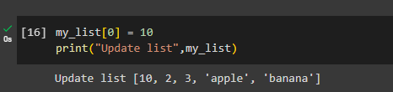

  - Assigning multiple values

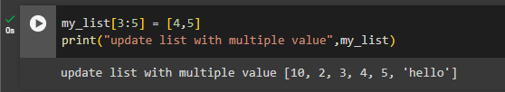

  - Length of list
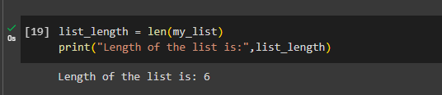

  - Append the element
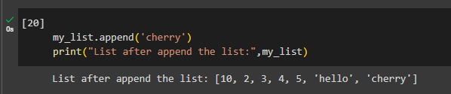

  - Remove the element

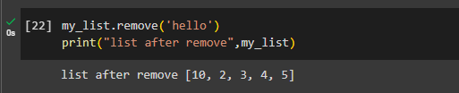

  - Copy the list
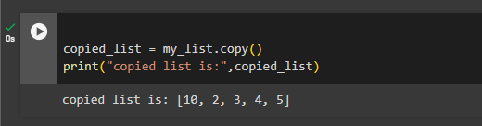

- Control flow structure

- If -elif-else
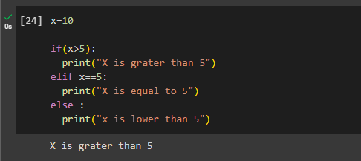

- While
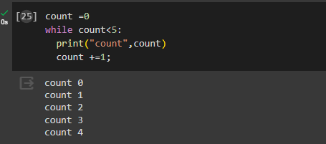

- For
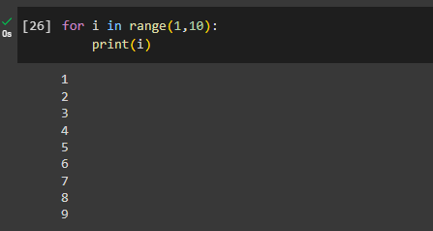

- Continue
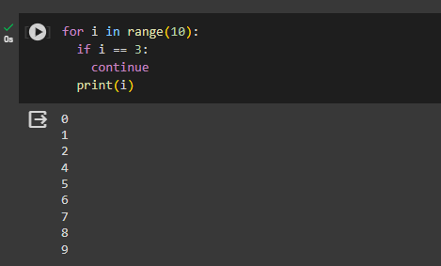

- Break
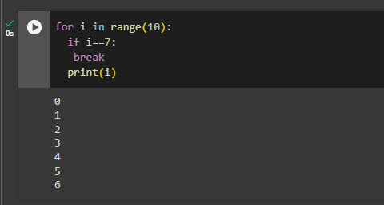

- Basic Function in python

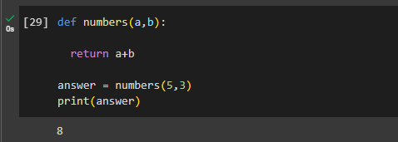

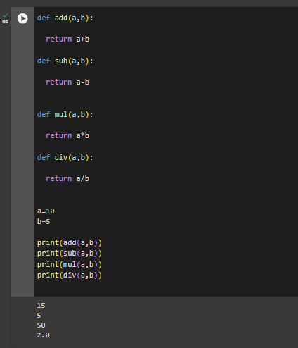

- Stack (Last In First Out (LIFO))

- Create the stack
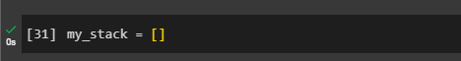

- Append the stack

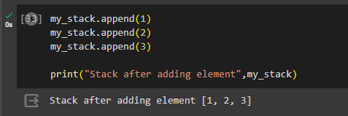

- Remove the element in stack

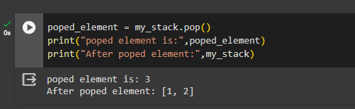

- Queue (First In First Out ( FIFO))

- Create the queue



- Insert the element in queue

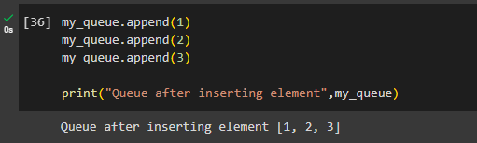

- Remove the element in queue

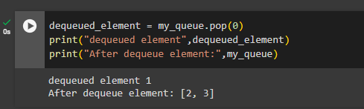

Exercises:

- Write a Python program to display the first and last colors from the following list.
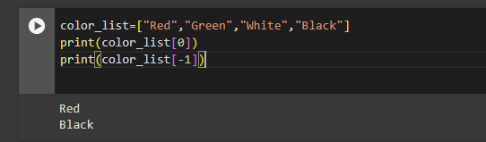
color_list = ["Red","Green","White","Black"]

- Write a Python program to get the volume of a sphere with radius six.
V = 4/3 Π r³
Π = 3.14159, r = 6
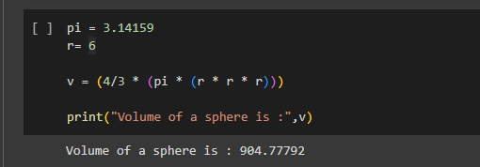

- Write a Python program to count the number 4 in a given list.
List- [1, 4, 6, 7, 4]

[1, 4, 6, 4, 7, 4]
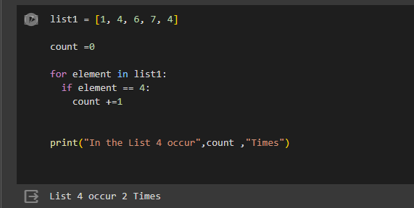

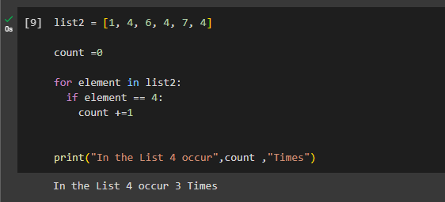

- Write a Python function to sum all the numbers in a list.
Sample List: - (8, 2, 3, 0, 7)
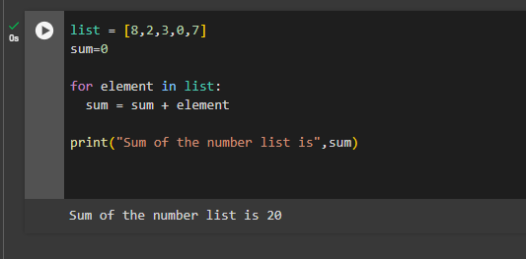

Discussion
The practical lesson in Python today went over a lot of basic ideas, such as basic math operations, string manipulation, list handling, control flow structures, functions, and data structures like stacks and queues. I had trouble with things like understanding syntax and finding and fixing mistakes while working on these topics. I overcame these problems by actively participating, asking the teacher for clarification, and using documentation and online tools. A lot of attention was also paid to coding techniques like organization, following style guides, problem-solving methods, and testing schedules. I learned a lot about Python programming and how it can be used in the real world by looking into both specific topics and more general parts of programming, like version control and real-world applications. Overall, the lesson gave me useful information and skills that I need to be able to program and solve problems well.

